Murrieta Mesa HS Rams Boys Basketball
Pre Order Form

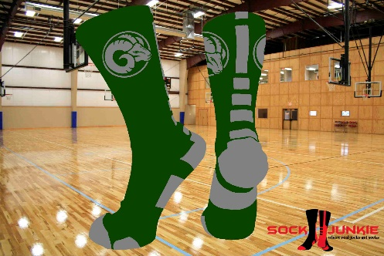 1 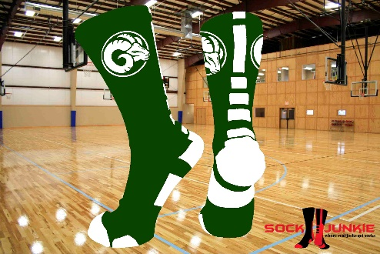 2
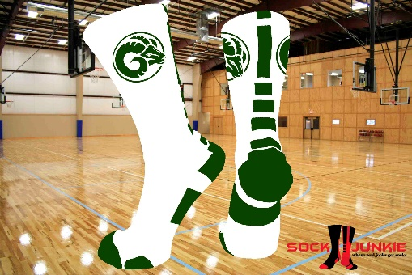 3

(Youth under 4) ( Small 4-6) (Med. 6-9) (Large 10-12) (X-Large 13+)

Sizes (small-xlarge) are based on men’s shoe sizes. When sizing for women go down 2 sizes. Example, woman’s size 10 would be size 8 in men’s shoe (size M in Sock Junkie socks).

www.SockJunkie.com

Design # | Youth qty | Small qty | Medium qty | Large qty | X Large qty
1
2
3

